Blog Page Template

Page Reference - <https://www.ancestry.com/corporate/blog/ancestryvolunteers-ancestry-2022-global-week-service>

This template is used for US blog overview and US Press release overview page.

Basic Tab

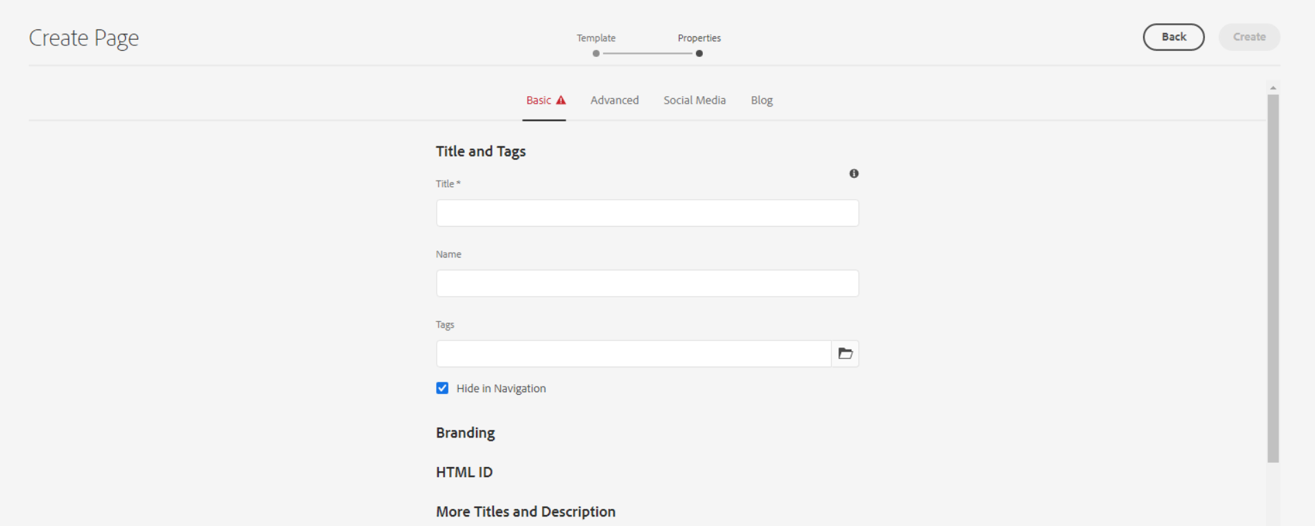

**Title** – Defines the page meta title for SEO, as well as a title displayable in the page content (unless an overriding 'Page Title' is defined).

Copy title from view source code

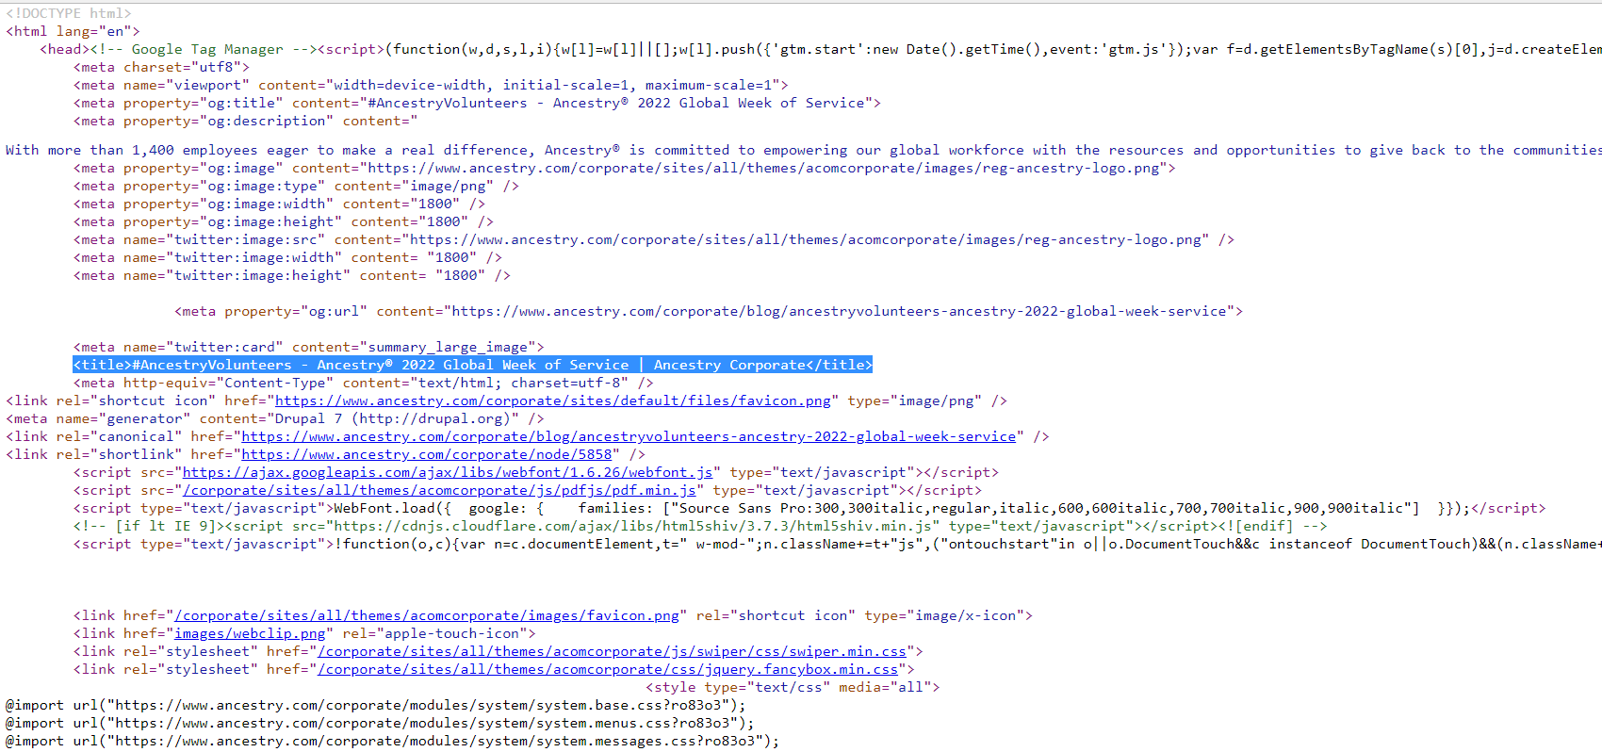

For E.g. : #AncestryVolunteers - Ancestry® 2022 Global Week of Service | Ancestry Corporate

**Name** – It should be the page name or URL of the page.



For e.g. : ancestryvolunteers-ancestry-2022-global-week-service

**Tags** – Defines the page meta tag for SEO

**Checkbox for Hide in Navigation** – This is for hide the page from header navigation.



**Page Title** - Defines a page title that is displayable in the page content, instead of the 'Title'.

**Navigation Title** - Defines a navigation title that is displayed in site navigation menus, instead of the 'Page Title' or 'Title'.

Advanced Tab

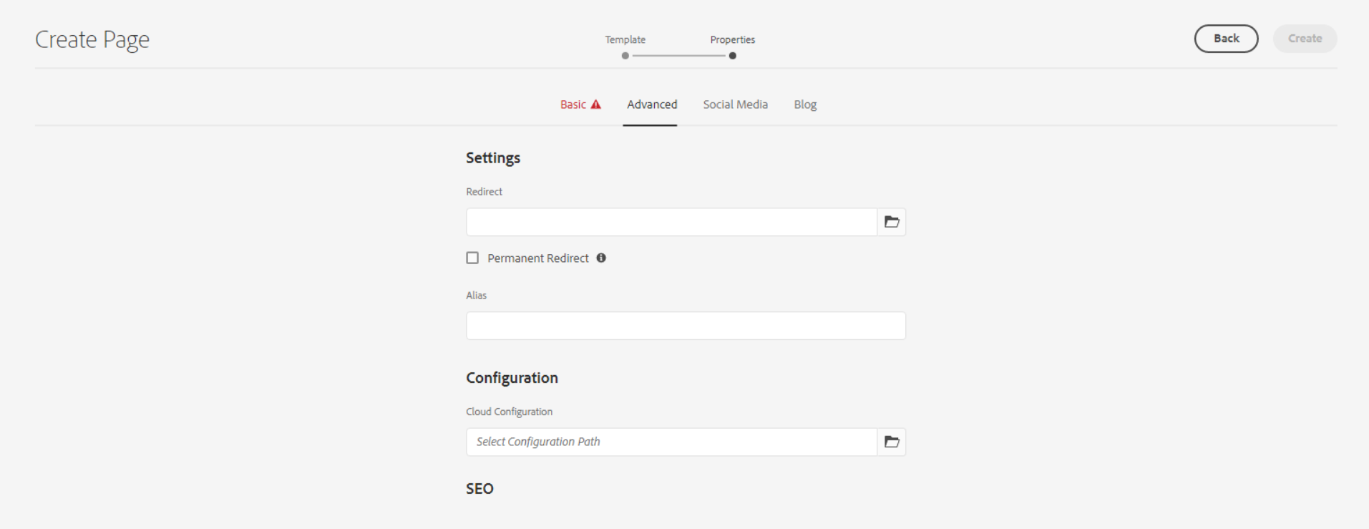

**Redirect** – Here we can set the internal or external redirect path

**Checkbox for Permanent Redirect** – can be checked to enable Permanent Redirect.

Social Media Tab

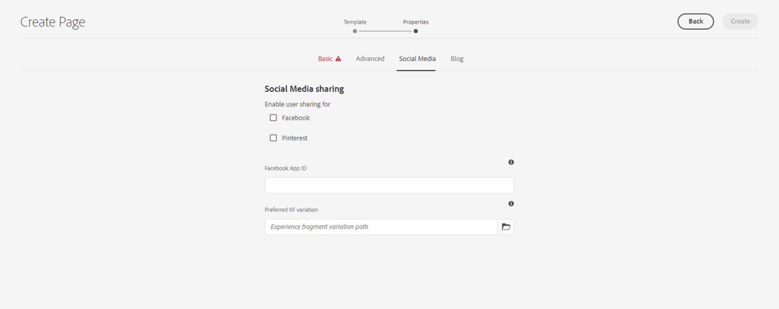

This is for social media Sharing.

Blog Tab

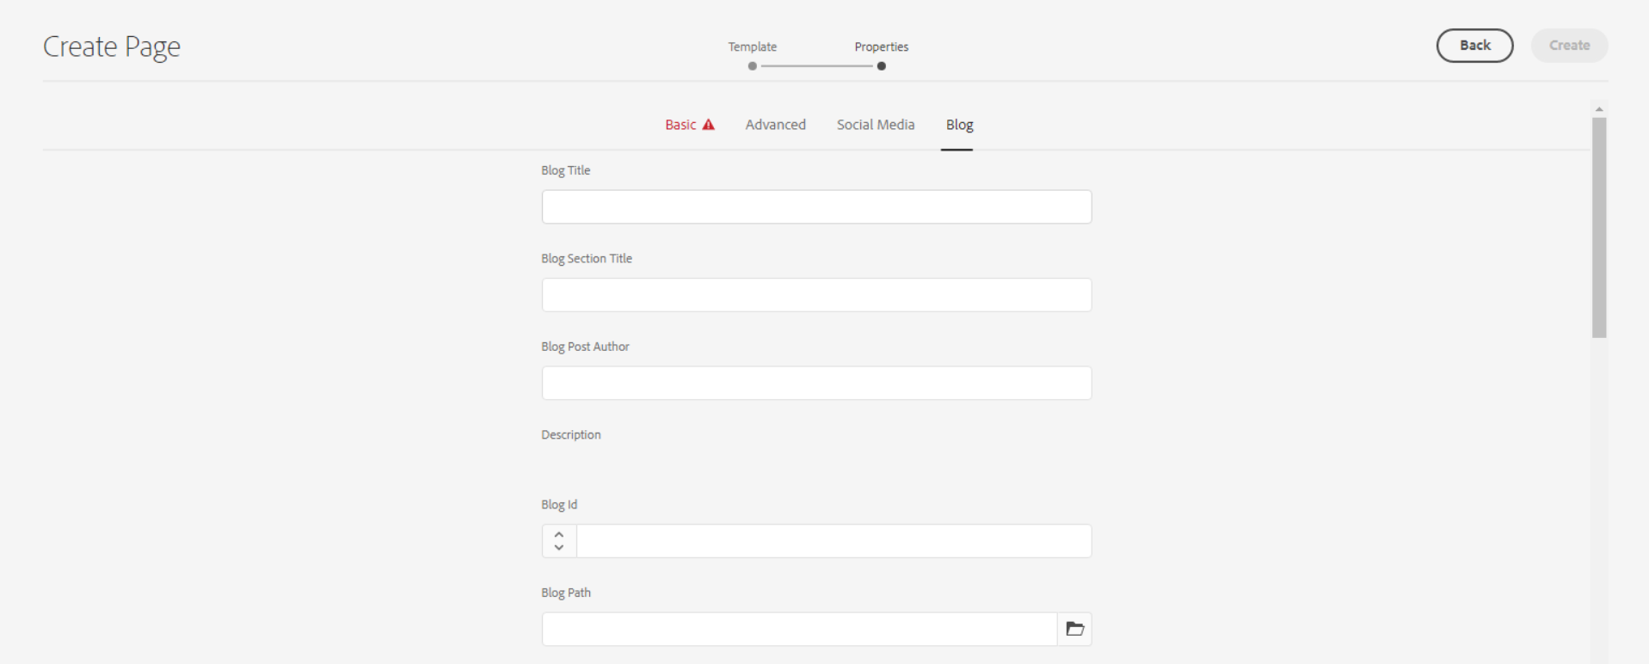

**Blog Title** – This is for blog title.

**Blog Section Title**

**Blog post Author –** This is for author name will be visible in hero banner caption section.

**Description –** This field is required for search your blog/press-release in search page. We need to update here meta description or first 2-3 lines from your page body description part.

Search Page - <https://www.ancestry.com/corporate/search-page>

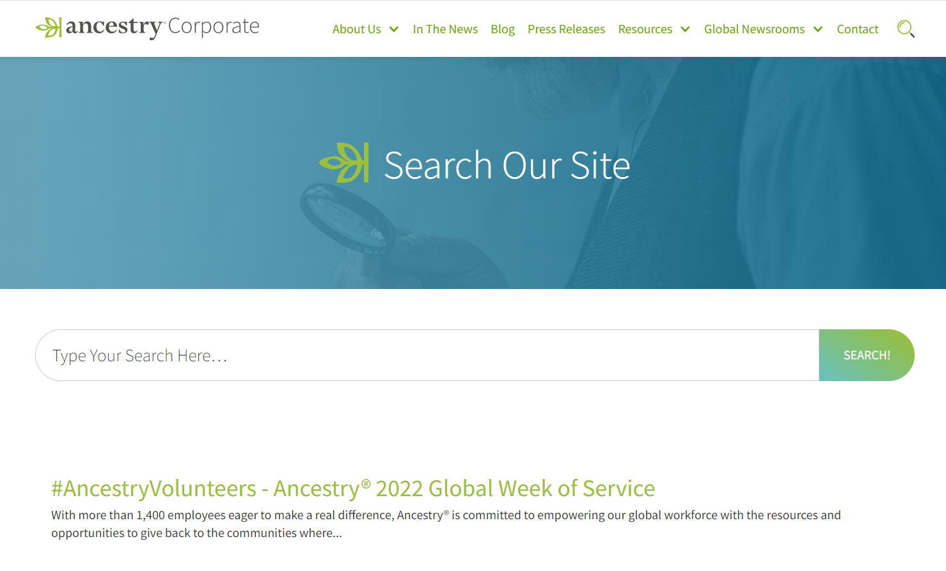

First way to copy description from view source code I.e. meta description

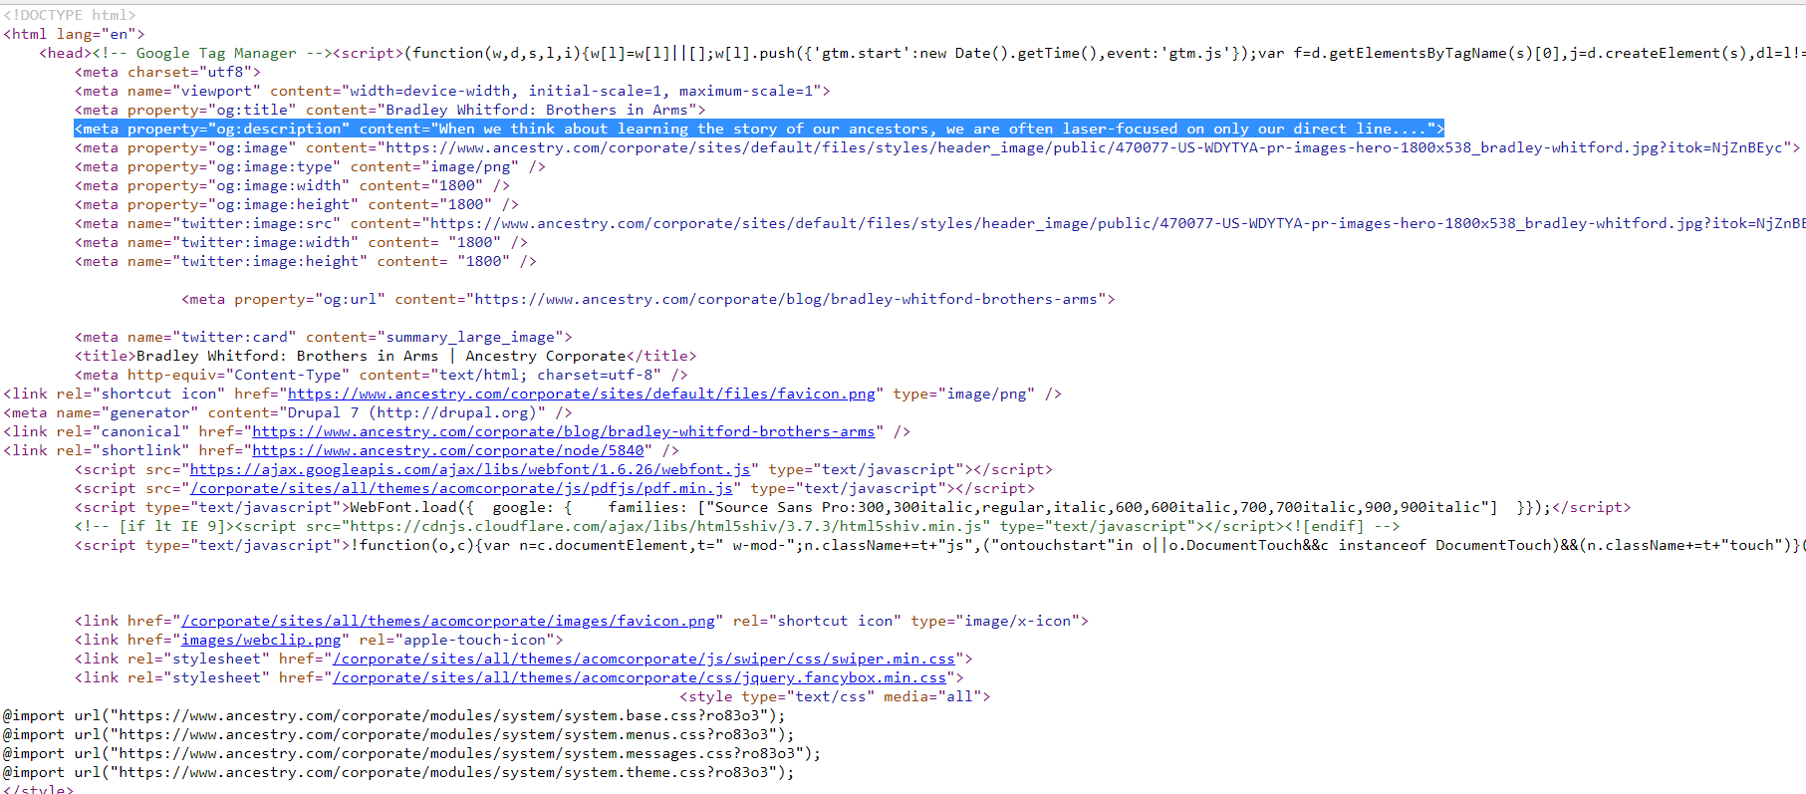

For e.g. : With more than 1,400 employees eager to make a real difference, Ancestry® is committed to empowering our global workforce with the resources and opportunities to give back to the communities where...

------------------------

The second way to copy the description from the blog body part is to copy the first 2-3 lines and add them in the description field. 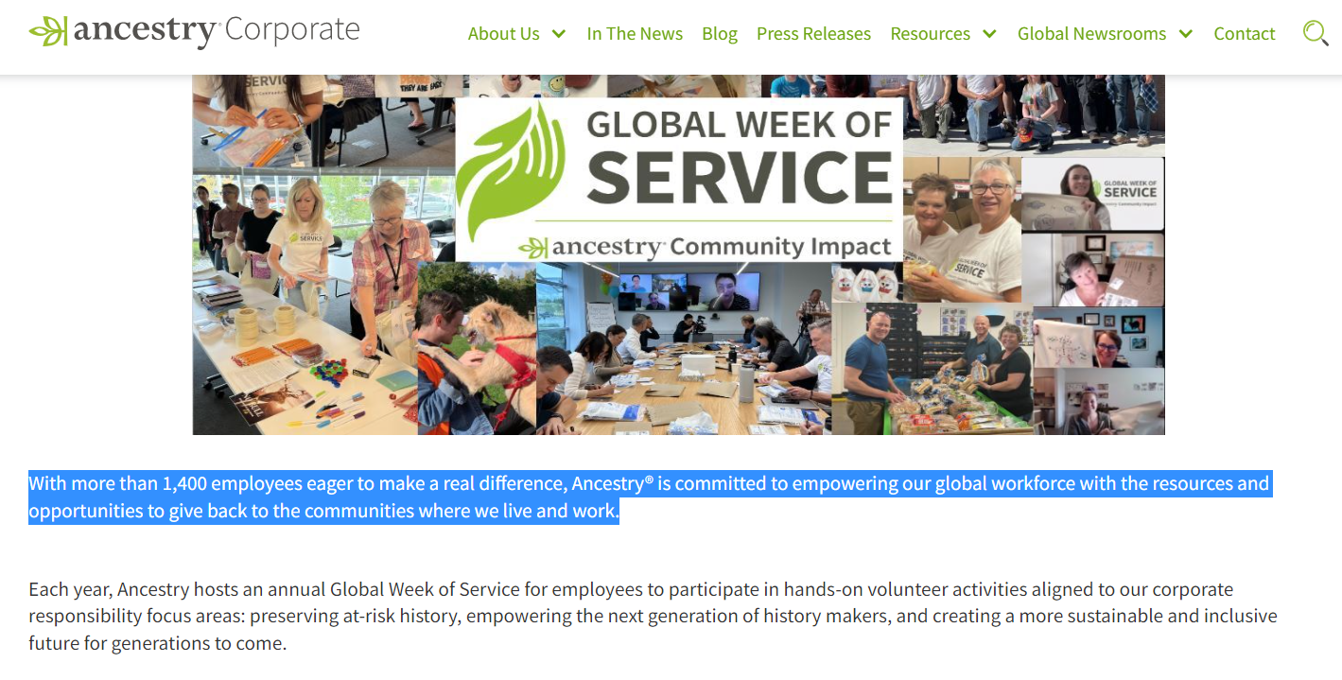

**Blog ID**

**Blog Path**

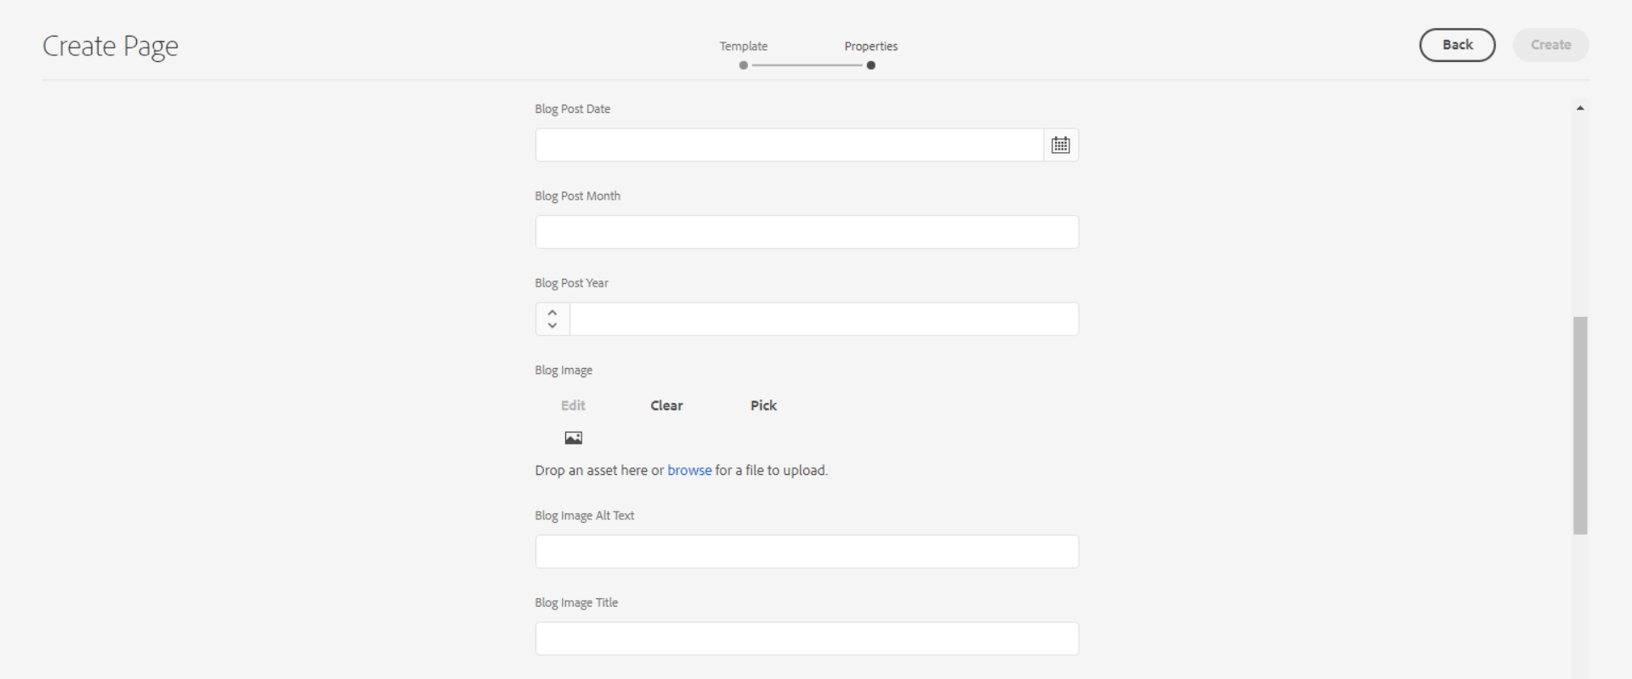

**Blog Post Date -** This is for postdate will be visible in hero banner caption section.

**Blog Post Month** – This is for month of blog post

**Blog Post Year** – This is for year of blog post

**Blog Image -**

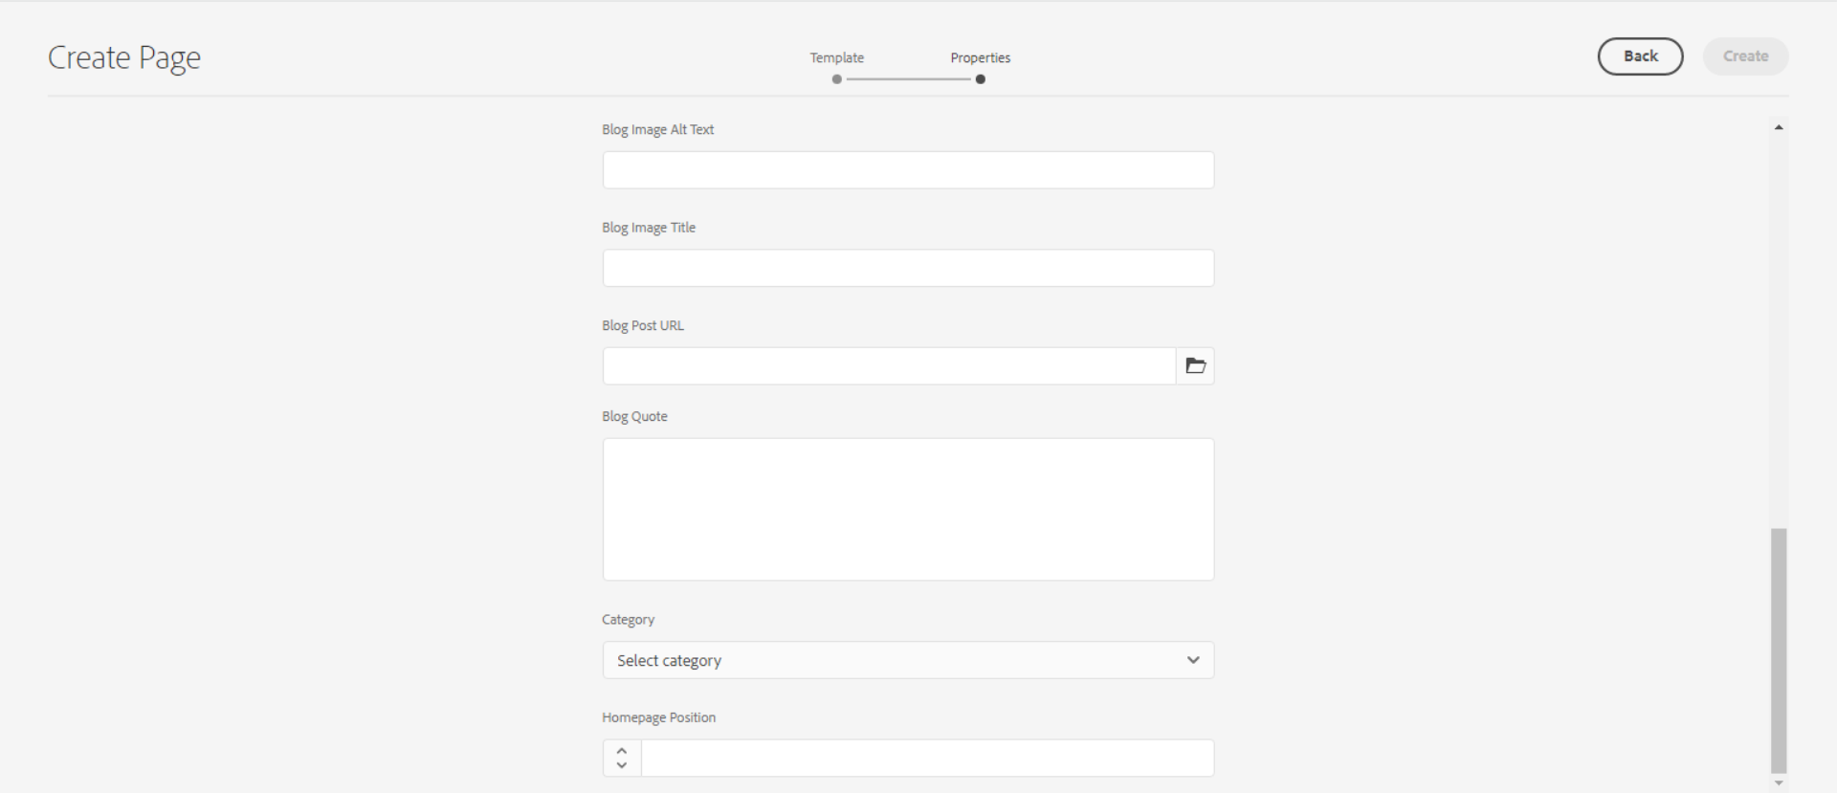

**Blog Image Alt Text**

**Blog Image Title**

**Blog Post URL**

**Blog Quote** – This is for blog quote text

**Category** – If we want to show our blog on the corporate responsibility page then we need to select category from the dropdown as corporate responsibility news.

corporate responsibility page - <https://www.ancestry.com/corporate/corporate-responsibility>

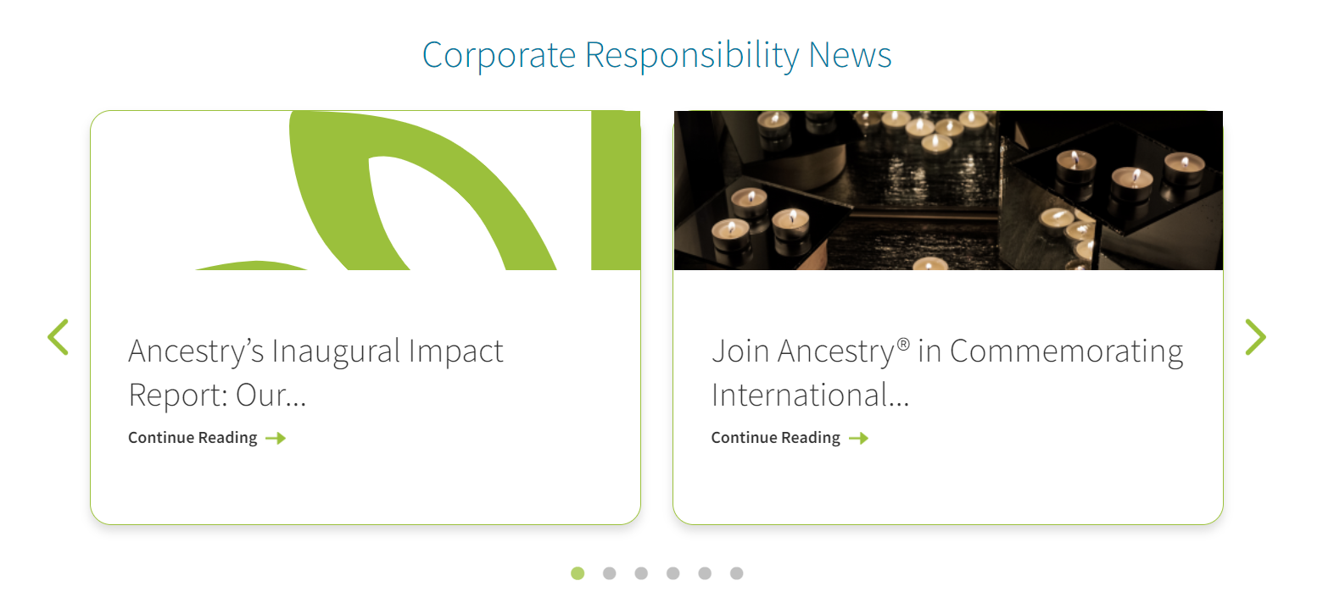

**Homepage Position** – If we want to show our blog on the Homepage as featured blog post then we need to add any one numeric value from 1-9 in this field.

Keep it blank if we don’t require on homepage.

<https://www.ancestry.com/corporate/>



Thumbnail Tab

Here we can add thumbnail image of the page.

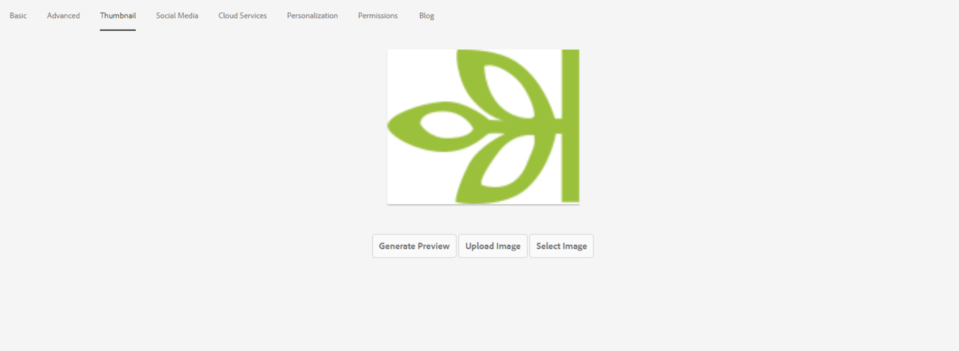

After creating the blog and again go back to properties then we can able to see featured Image option inside the blog tab. That featured image will be visible on the listing page of our respective blog.

Blog Listing Page - <https://www.ancestry.com/corporate/blog>

